Final evaluation against the specifications
Lemon Meringue Pie

Specification | Did your LMP satisfy this specification? How? Justify. | Evidence  Eg photographic, results of sensory evaluation
- has a base that is not soggy and cuts into a serving without crumbling | The base was slightly undercooked but it was not soggy as the lemon filling did not have any fluid that could make it soggy. When I cut a piece out, the piece stayed intact.  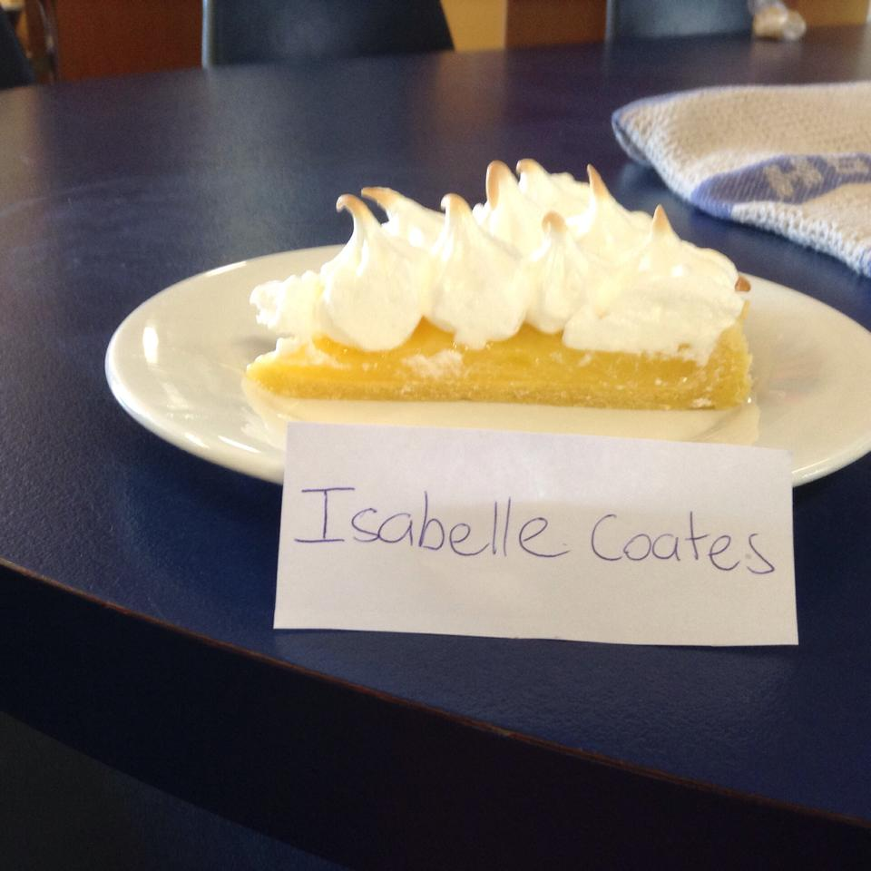 | 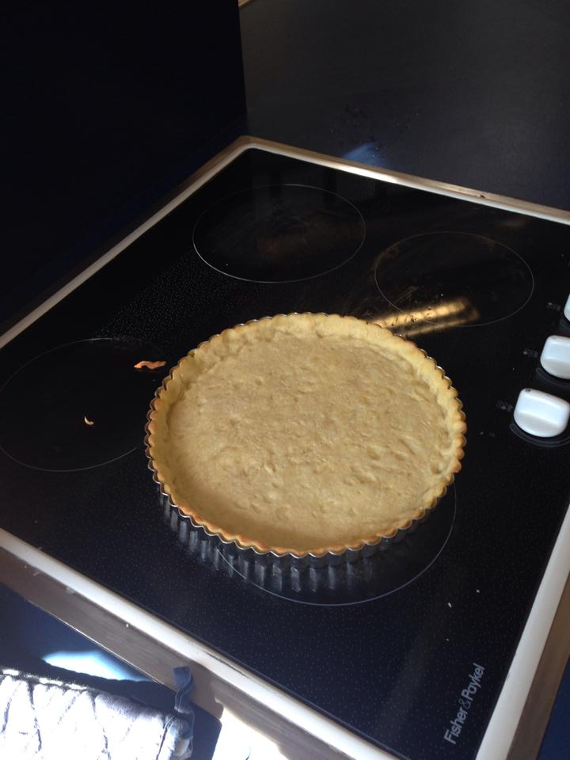
- has a meringue topping that is browned and is ‘attached’ to lemon filling | I used a fork to make cross hatches in the lemon filling and this made the meringue stick to the lemon filling, The meringue was slightly browned on top but meringue was a tad soft so could have been cooked longer.  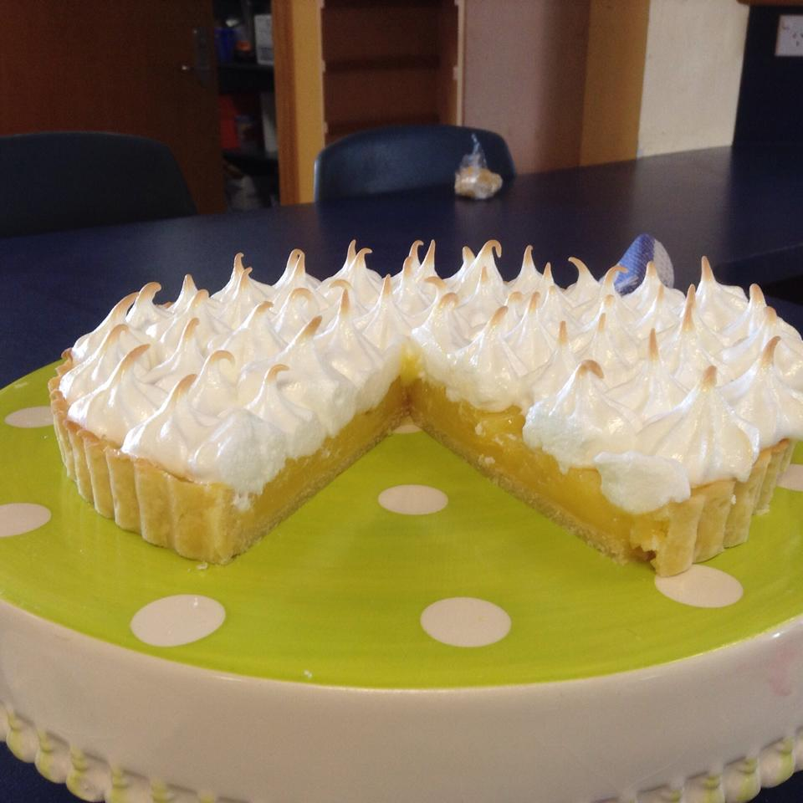 | 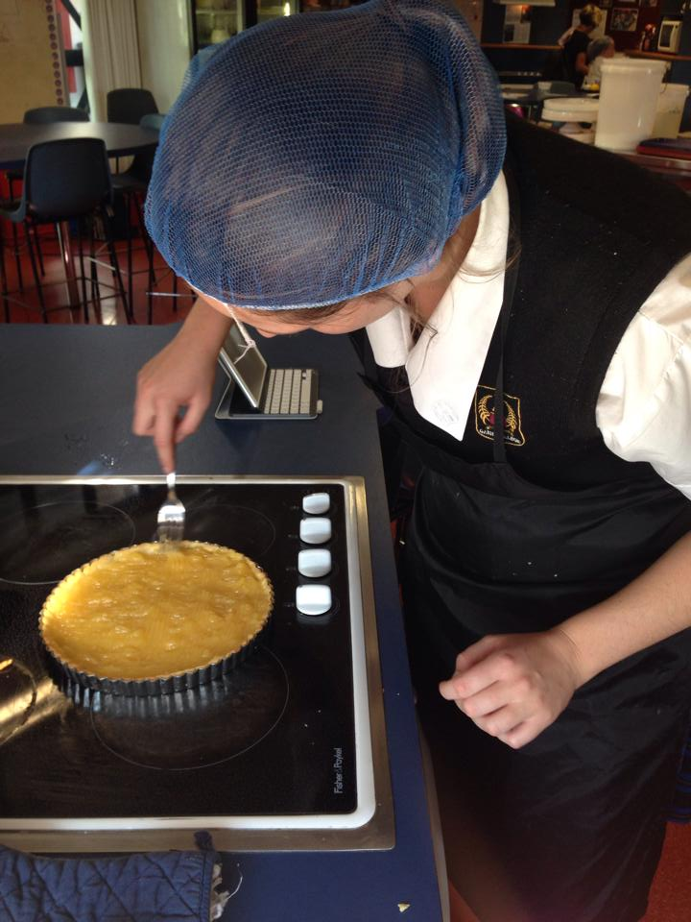
- acceptable proportion of base to filling to meringue | The filling was an acceptable thickness compared to the meringue and base. There wasn’t too much filling so it didn’t overpower the other components. There could have been more meringue but the overall combined flavour was still good.
- pie fits flan dish | The pastry had shrunk a little bit this was due to over handling the pastry but it was only about 2mm so it wasn’t a lot.  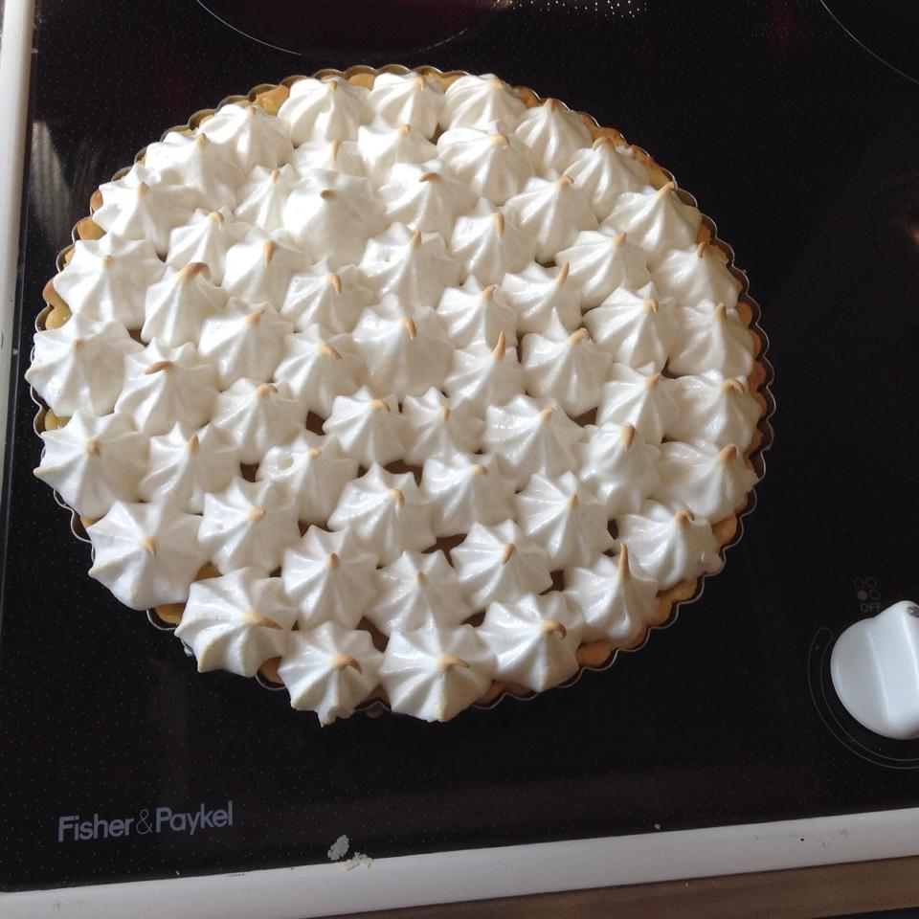
- is edible. | The pie is definitely edible and did not cause anyone food poisoning. | 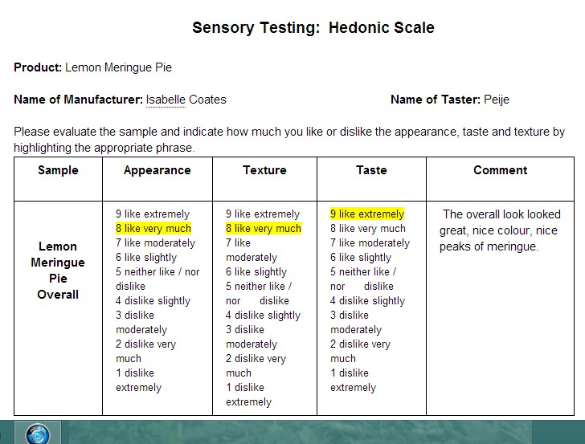
- Smooth consistency for lemon filling | My lemon filling met the specifications as it has the right viscosity and i used a sieve to remove any lumps | 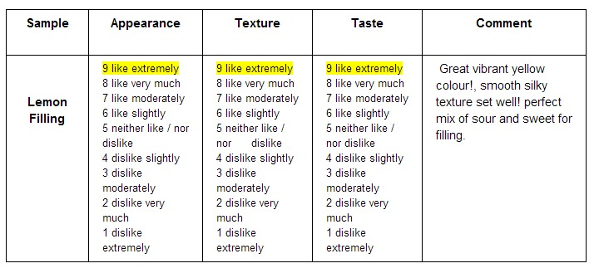
Lemony flavour for filling.  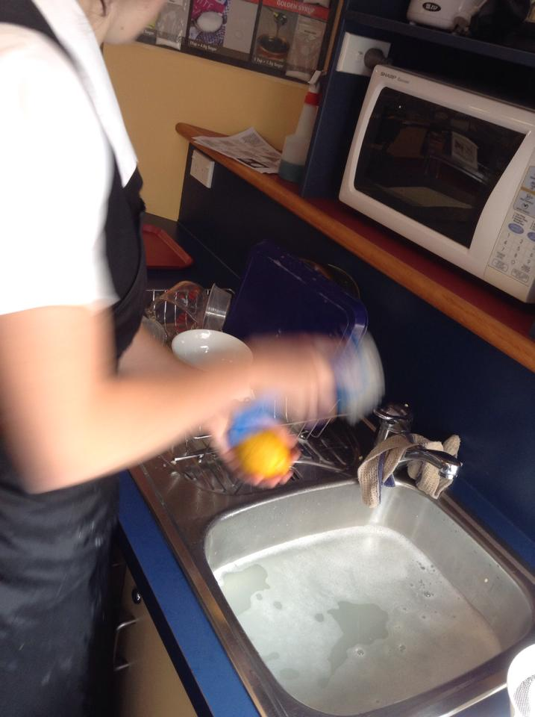 | To ensure I has the best lemony flavour, I scrubbed the lemon zest to get rid of the dirt on the skin. This ensures that the zest would have the best possible lemon flavour. I also used home grown lemons as they have the most richest lemon flavour because bought ones have often been sprayed with chemical and cleaned and shined, this takes away the some of that rich lemon flavour. | 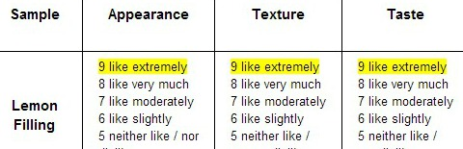
even, piped meringue | I met this specification as I piped my meringue evenly, I also used the largest nozzle I could find to ensure there was enough meringue  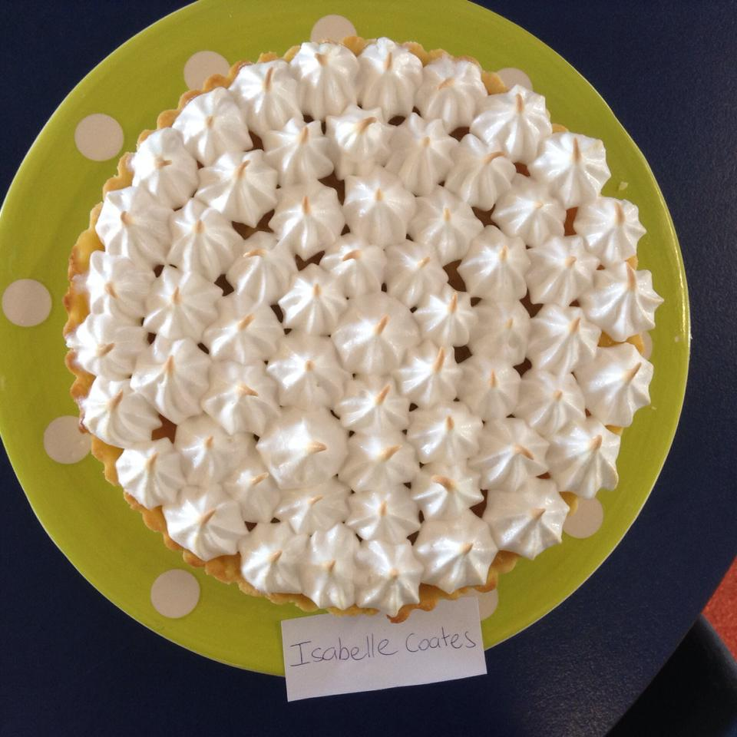 | 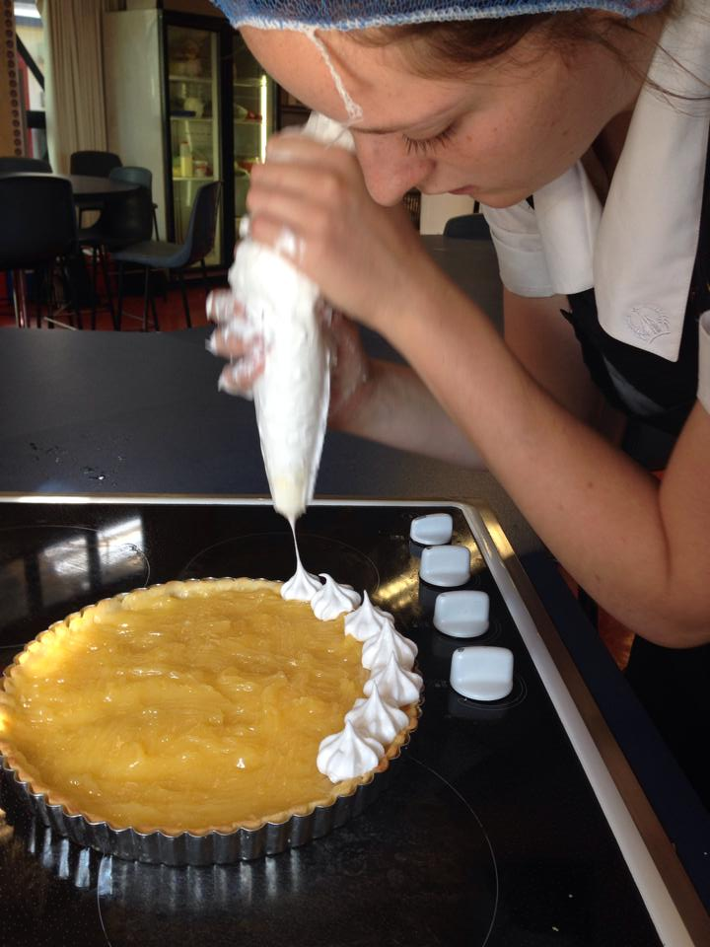

Conclusion:
Overall I think my pie turned out pretty good, the filling definitely being the best part. The crust of my pastry shell, was good as it was golden but my base could have been better as it was slightly undercooked. I think I should have taken my cartouche off sooner because then the pastry crust and base would have been at the same stage but because I didn’t want my crust to burn I took the pie out of the oven when it could have been in there longer. Another fact as to why my base was undercooked was because I had trouble getting the pastry into the pan so to overcome that, I patched it all together in the pan, this meant that the bottom was a little uneven and thicker than the crust.

My lemon filling had the perfect viscosity and flavour, it was also smooth and when the pie was cut open, the filling did not run out as it had the right thickness. Because I got my lemon filling almost perfect, it meant that it didn’t affect the other components. Because it wasn’t runny, my base did not go soggy and the meringue stuck to the top.

My meringue was perfectly beaten as it was silky, smooth and stiff, I stuffed it up when it came to cooking it as I personally think that the meringue is cooked when just the tips are golden but the specification states that the meringue crust must be golden brown, so my meringue was slightly undercooked and that made it a little soft but it still held together perfectly when cut.

